# COMP3500: Memory Management Part 1 - Review

**Exercise 1 (Plickers):** Which one of the statements is the benefit of the best-fit strategy?

A. Fast

B. Good storage utilization

C. Minimize internal fragment

D. Easy implementation

**Exercise 2 (Plickers):** Which one of the statements is the benefit of the worst-fit strategy?

A. Fast

B. Good storage utilization

C. Minimize internal fragment

D. Easy implementation

**Exercise 3 (Plickers):** Which one of the statements is the benefit of the first-fit strategy?

A. Fast

B. Good storage utilization

C. Minimize internal fragment

D. Comprehensive implementation

**Exercise 4 (Plickers):** Which one of the following statements about static memory management is *incorrect*?

A. A program may be too big to fit in a partition

B. Main memory utilization is efficient

C. Wasted space due to internal fragmentations

# COMP3500: Memory Management Part 2

**Exercise 5 (Plickers):** Which fixed partitioning design will you choose to implement? Why?

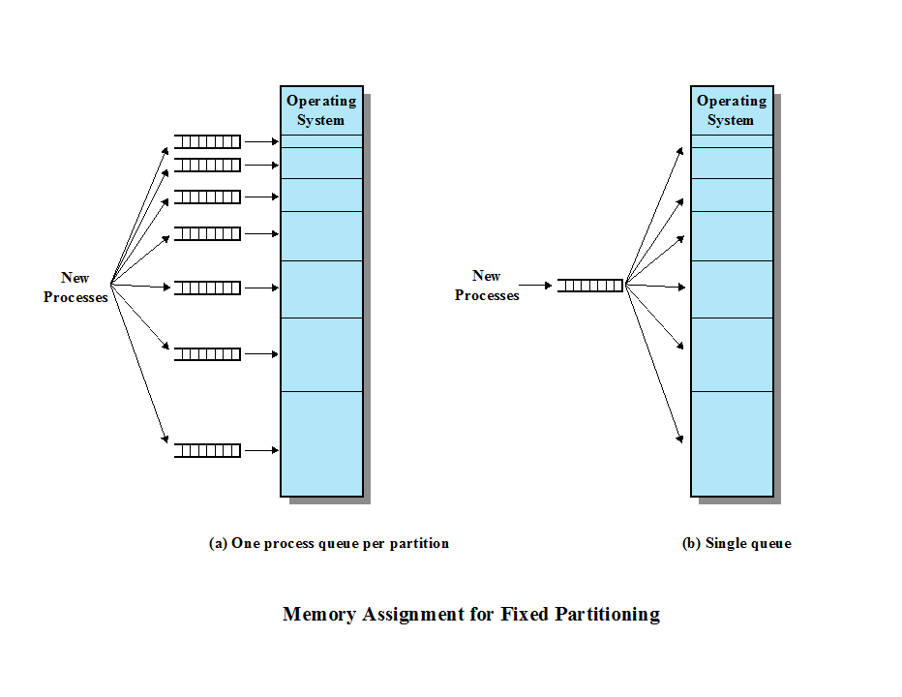

**Exercise 6 (Plickers):** What is a problem with dynamic partitioning?

A. Flexibility B. Internal fregmentation

C. Small holes D. All the above

**Exercise 7:** Which slot do Best-Fit, First-Fit, and Next-Fit allocate for 16-MB block?

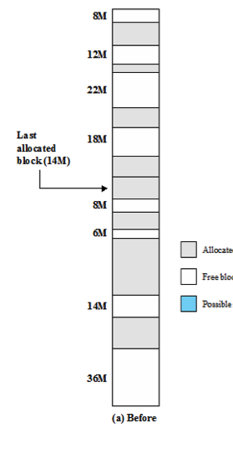

**Exercise 8:** What is the page tables for process B, C, D at time f?

